PROGRESS REPORT

Title: Concentration Memory Card Matching Game

Group 10:

Shawn Stewart

Jonathan Brunssen

John Atillo

Carlos Ravago

Dylan Morales

James Robertson

1. Scope AND Purpose

The game is designed to enhance the users ability to produce repetitive memory content. The user needs a way to stimulate their short term memory capabilities. The game will consist of a NxM (depending what looks best on screen) grid space that contains 12, 24, or 36 tiles depending on users choice. Score will be tracked by gaining a point for getting a pair correct and losing a point for an incorrect pair, where the user's best and average score is tracked for the day and can be compared to the day prior average. By tracking the computer generated results of the user’s response, the user can make an assessment as to how they are progressing.

2. Individual Contribution

Shawn Stewart-Helped establish app purpose and capabilities, created and helped with progress report.

Jonathan Brunssen- Created GitHub, decided memory card game idea, helped establish app purpose and capabilities.

John Atillo- Helped with progress report , helped establish app purpose and capabilities, contributed towards levels of difficulty.

Carlos Ravago- Contributed card images, constructed memory card game foundation, added animals to cards.

Dylan Morales- Constructed class diagram.

James Robertson- Helped establish app purpose and capabilities.

3. Work Progress

Sep 29th - Created github.

November 14th - group meeting to discuss further roles and actions that need to be taken.

November 26- Started constructing the memory card game using html with formulated ideas.

November 29-30- Completed foundation of memory card game.

4. Application Snapshot

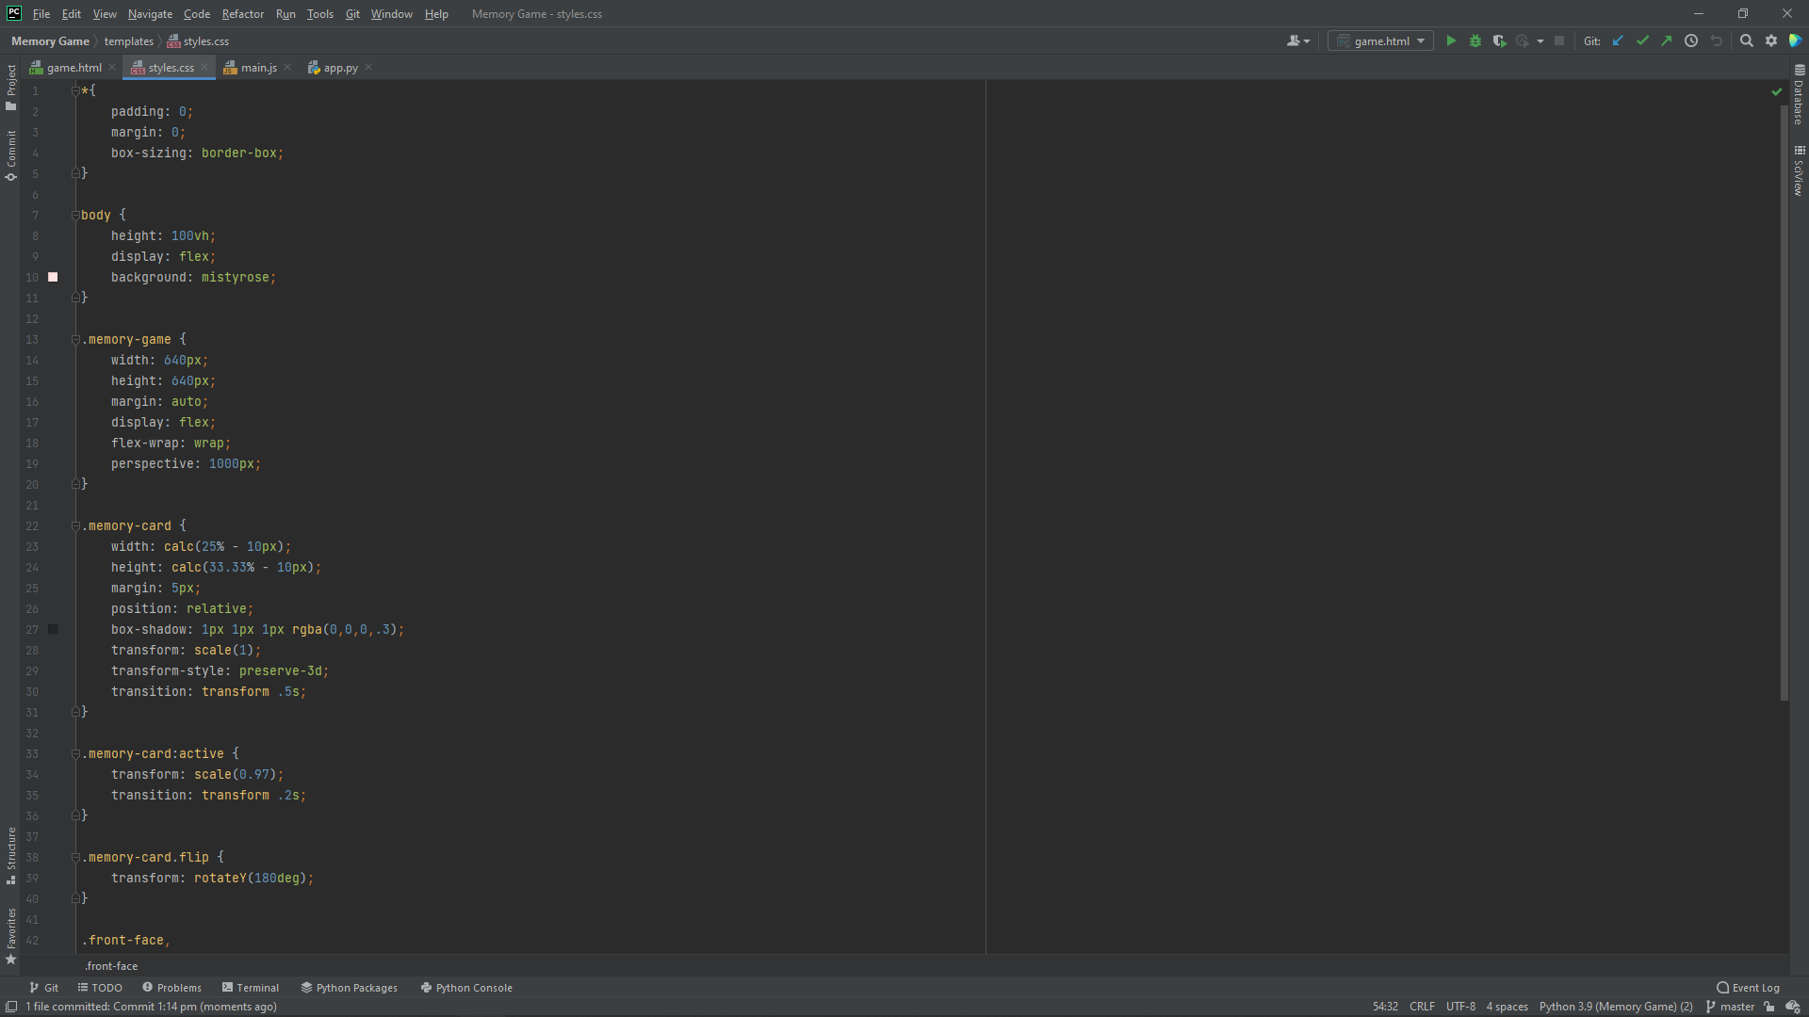

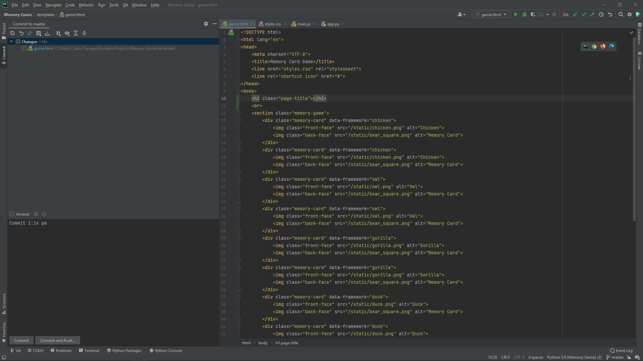



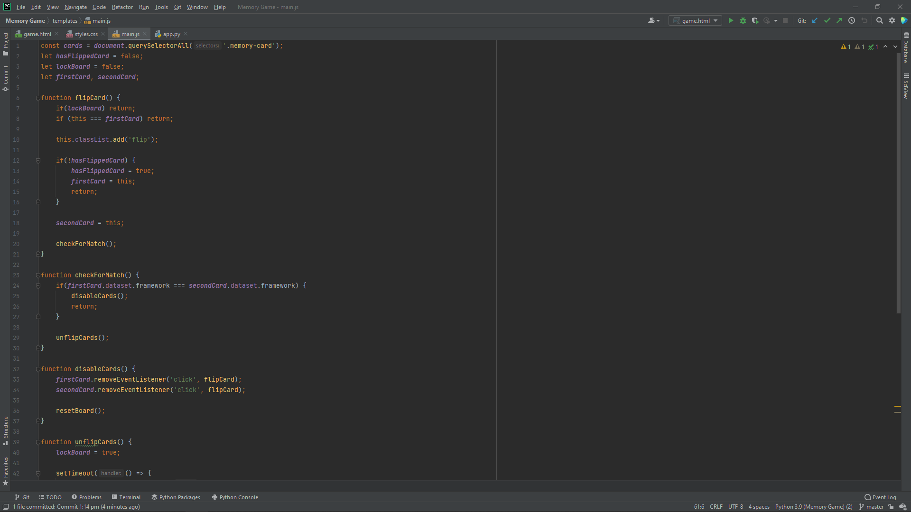

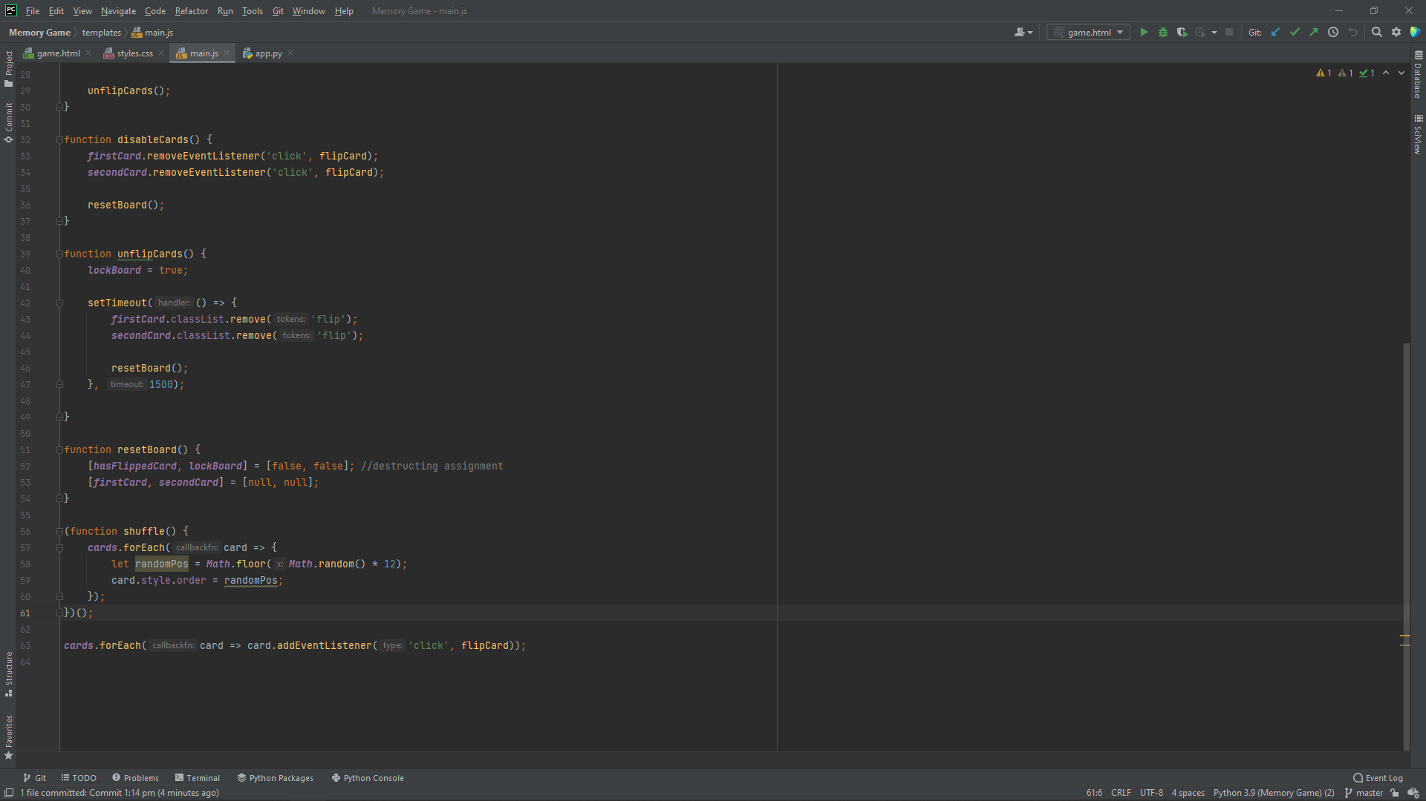

5. Remaining Work

Some remaining work that needs to be done is to include styling designs. It also needs to include the proper memory card animal choices. We have to include a progress bar and the users ability to save the game and continue later. We also have to include a scoring mechanism for the users data based on accuracy or numbers of flips for cards that aren't matching.

We also have to fix the different grids to allow the user to pick the difficulty level based on the chosen grid.

6. Issues

Issues that we are currently facing with our project is the different levels of difficulty and finding a

relevant way to score this game. Another issue that we ran into was finding proper pictures that were the

correct pixel size, this was an issue because the pictures had to be same in size for the program to run

Smoothly. Another issue we ran into was locking the board meaning that if we clicked on another set of cards

before the initial flip reset, the cards would stay flipped over. Along with that double clicking the cards

would leave that card flipped over.